**How to enable Realtek Repeater Self-Organization Network**

|  |  |  |
| --- | --- | --- |
| 2017/07/20 | Aries Lee | Ver 0.2 |

1. Introduction

Realtek Repeater Self-Organization Network is a private software protocol which allows all devices to construct and maintain the network topology automatically. All devices which’s with the same identity (we call RSON ID) will connect each other in the form of tree structure. If any node is deleted or added, all nodes can automatically reconstruct a new network topology to adapt any change.

Since the network will form a hierarchical tree structure. The top of the tree is called “Root”, which only operates hostapd function to allow to be associated by other devices. The STA interface of Root is NOT necessary to be active.

On the other hand, the rest parts of the tree are called “Nodes”, which be required to operated not only hostapd but also wpa_supplicant at the same time, the STA interface of “Node” MUST connect to tree and the AP interface of “Node” MUST allow to be connected by other node as well. We also define a term -- “Hop count”, which means the number of edges from the Root to the Nodes, it also represent the hierarchical level for a node in the tree

Following figures show the process of each stage during RSON working.

Attention!! A linking was UNABLE to be established between a peer and a peer unless both of them have the same RSON ID.

* All devices are just power on, RSON function is preparing.

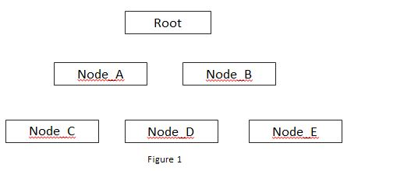

* All devices have constructed a tree structure networking by RSON function.

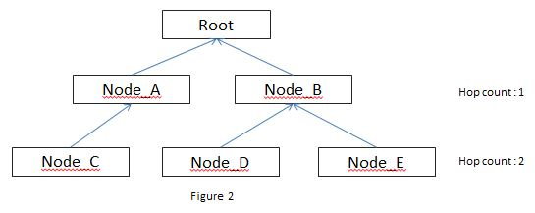

* If a node is disconnect for some reason, RSON function will recovery the connection of whole networking.

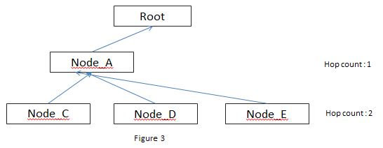

1. Driver configuration
   1. Please **make sure that all devices can perform repeater mode well**, you have to run hostapd and wpa_supplicant at the same time, if you have no idea about how to enable repeater mode function, please reference the documents -- “Quick_Start_Guide_for_Bridge.pdf” and “Realtek_WiFi_concurrent_mode_Introduction.pdf”.
   2. Set **CONFIG_RTW_REPEATER_SON** as y in Makefile
   3. Edit include/autoconfig.h, put following string in file.

#define **CONFIG_RTW_REPEATER_SON_ID** 0xXXXXXXXX

Where “0xXXXXXXXX” is an 4byte hexadecimal number which’s used as an identity of network. The devices with the same CONFIG_RTW_REPEATER_SON_ID value will consist of the same network. On the other hand, the devices with different ID would NOT try to connect each other even they have the same SSID and password.

* 1. If this device is a root (ex:NVR), please put following string in include/autoconfig.h.

#define **CONFIG_RTW_REPEATER_SON_ROOT**

If this device is a node (ex:IPCAM), do NOT define this flag.

* 1. All device which’s in the same network should use the same channel, SSID, password, encryption way. In other words, the content of hostapd.conf and wpa_supplicant.conf should be the same.

1. Technical detail

This table shows the parameters of “Realtek Repeater Self-Organization Network” mechanism.

|  |  |
| --- | --- |
| **Name** | **Explanation** |
| Version | Version |
| ID | Different network should own a different ID. |
| HopCount | Hop count |
| Connectible | Whether the AP allow to be connected or not  1 : allow  0 : deny |
| Loading | The traffic loading |
| Reserve | Reserve |

The file “/proc/net/<wifi_chip>/wlanx/rson_data” allows the developers to get/set those parameters.

* How to get parameter?

**cat /proc/net/<wifi_chip>/wlanx/rson_data**

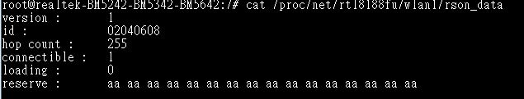

* How to set parameter?

**echo <field> <val> > /proc/net/<wifi_chip>/wlanx/rson_data**

where <field> is the parameter name and <val> is the value you want to assign.

Ex :

echo ver 1 > **/**proc/net/rtl8188eu/wlan0/rson_data

echo id 0x01020304 > **/**proc/net/rtl8188eu/wlan0/rson_data

echo hc 1 > **/**proc/net/rtl8188eu/wlan0/rson_data

echo cnt 1 > **/**proc/net/rtl8188eu/wlan0/rson_data

echo loading 1 > **/**proc/net/rtl8188eu/wlan0/rson_data

echo res 11223344556677889900aabbcc > **/**proc/net/rtl8188eu/wlan0/rson_data

For debugging purpose, developer can observe the content of /proc/net/<wifi_chip>/wlanx/survey_info, it shows a list of all detected nodes and their information in the air.

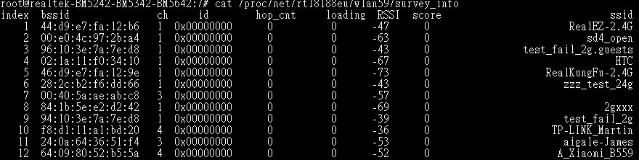

1. Note
   1. All nodes will detect whole system and automatically roam to better choice (if it exist) every 2 seconds.
   2. The node will detect the linking status of parent node, it would not report disconnection immediately. Instead, device will try to roam to the second choice and report disconnection if it is still unable to connect with any peer in next 6 seconds.
   3. “Realtek Repeater Self-Organization Network” function **only focus on constructing a layer 2 wifi networking topology**, this function DOESN’T take care IP, TCP/UDP, HTTP or any other upper network protocol/application.
   4. The criteria of choosing parent node is implemented in core/rtw_rson.c::rtw_cal_so_score() function. It is based on 2 factor ---
2. The hop count from the root.
3. RSSI.

The developer can customize this function by their user scenario.